**ARKADIPTA MOJUMDER**

**REGISTRATION NUMBER- 22MCA0201**

**LAB ASSESMENT 1- PYTHON PROGRAMMING(ITA6017)**

**1.Print the following pattern using for loop**

**1**

**1 2**

**1 2 3**

**1 2 3 4**

**1 2 3 4 5**

**Solution-**



**Output-**

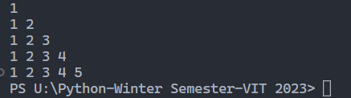

**2. Write a program to count the total number of digits in a number and also sum the value**

**using while loop.**

**Solution-**

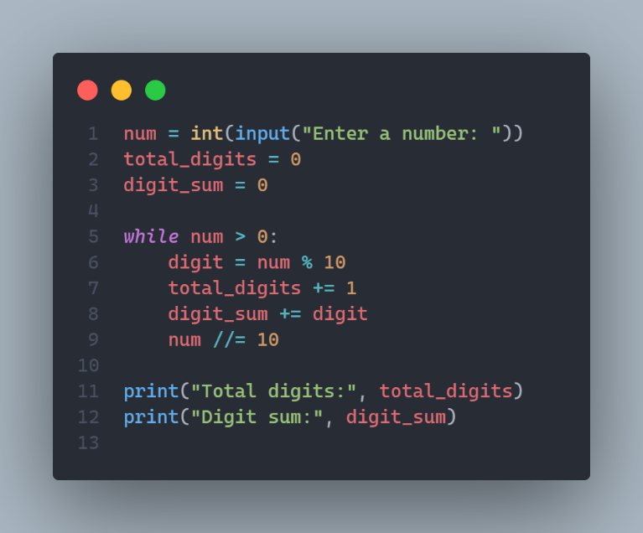

**Output-**

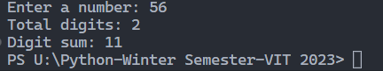

**3. Print the following pattern using for loop**

**5 4 3 2 1**

**4 3 2 1**

**3 2 1**

**2 1**

**Solution-**

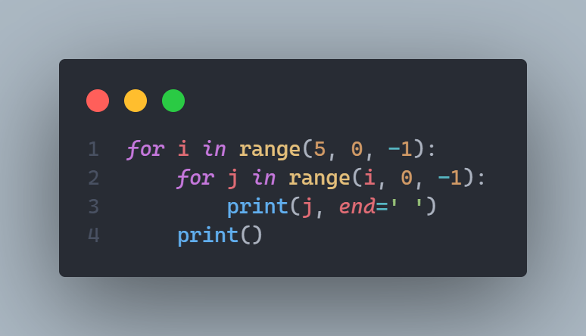

**Output-**

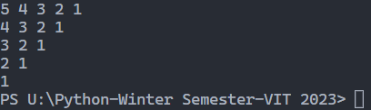

**4. Find the sum of series up to n term using loop.**

**if n =5 , series=2 the series will become 2 + 22 + 222 + 2222 + 22222 = 24690.**

**Solution-**

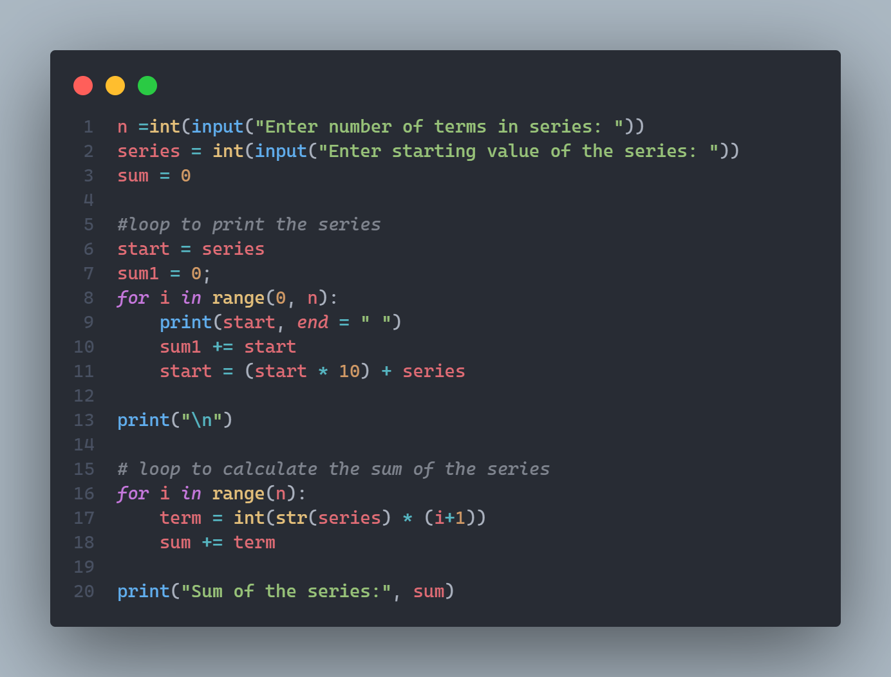

**Output-**

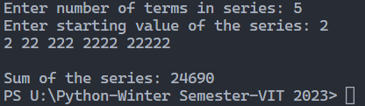

**5. Print the following pattern using for loop**

**\***

**\* \***

**\* * \***

**\* * * \***

**\* * * * \***

**\* * * \***

**\* * \***

**\* \***

**\***

**Solution-**

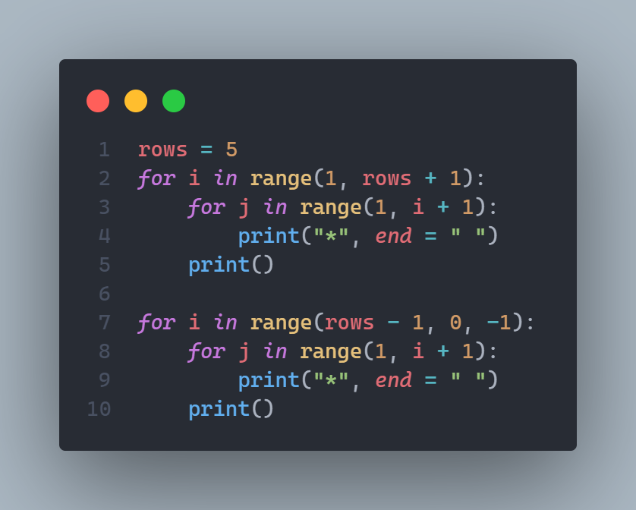

**Output-**

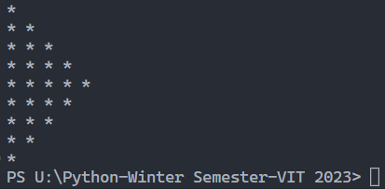

**6. Scenario Two trains are on same track and they are coming towards each other. The speed of the first train is 50 km/h and the speed of the second train is 70 km/h. A bee starts flying between the trains when the distance between two trains is 100 km. The bee first flies from first train to second train. Once it reaches the second train, it immediately flies back to the first train … and so on until trains collide. Calculate the total distance travelled by the bee. Speed of bee is 80 km/h. Calculate the Time Taken by the Trains to collide in minutes.**

**Solution-**

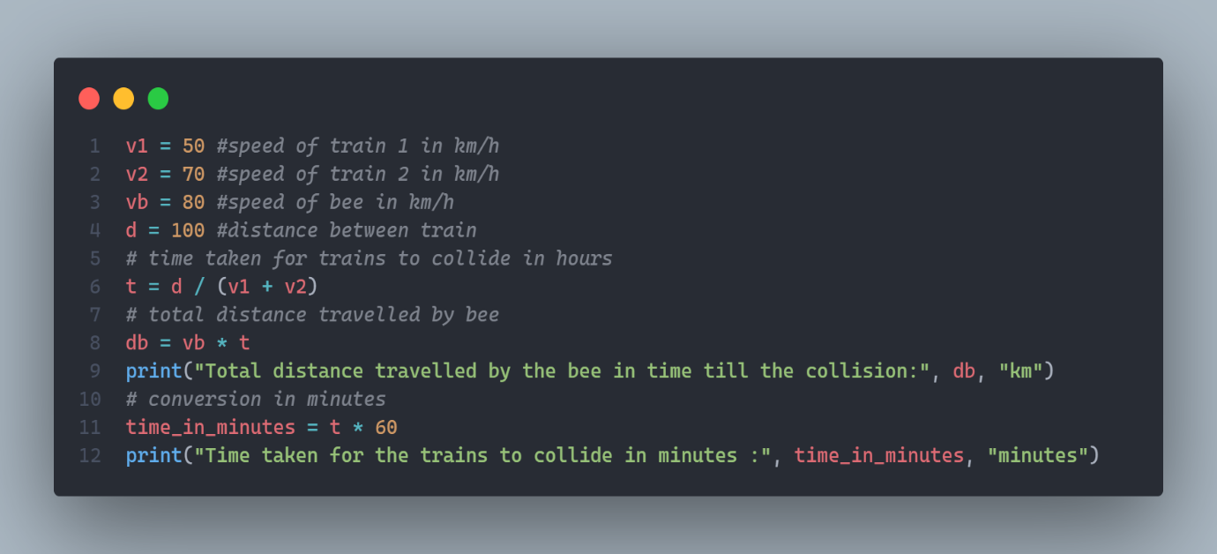

**Output-**



**7.Solve the following puzzle from range 1 - 10**

**1 + 1 + 1 = 41**

**2 + 2 + 2 = 142**

**3 + 3 + 3 = 363**

**4 + 4+ 4 = 764**

**Solution-**

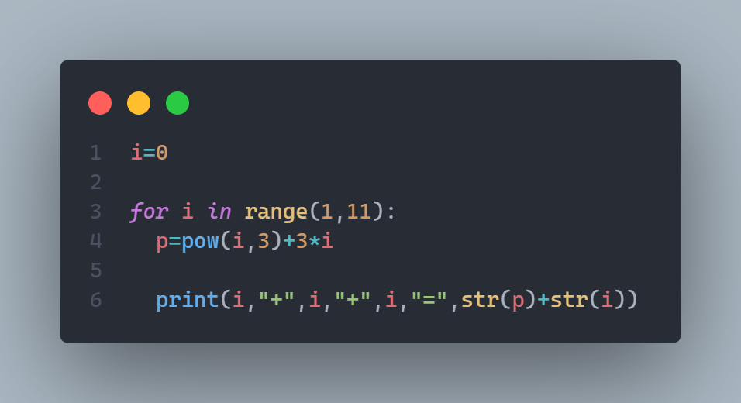

**Output-**

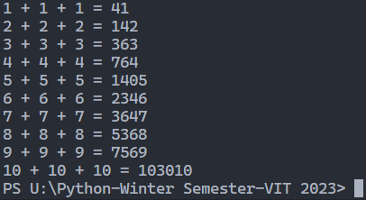

**8. Check whether the given no is perfect number or not**

**For example: Sum of the proper divisors of 6 is 1 + 2 + 3 = 6, which is a perfect number.**

Solution-

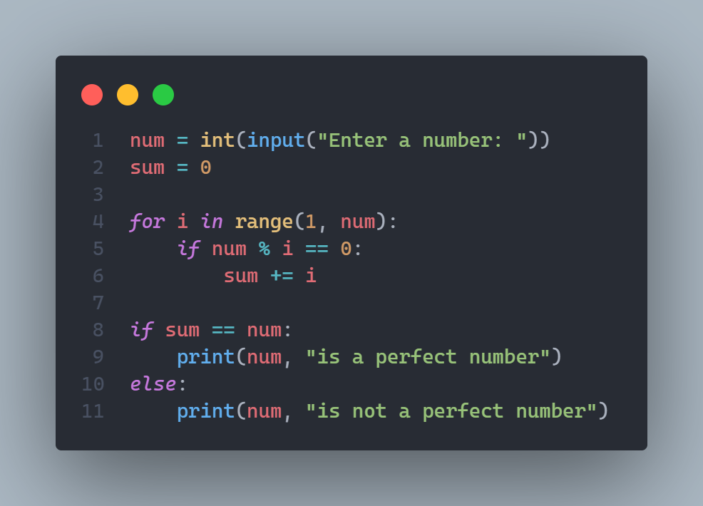

Output-

